|  |
| --- |
| Ravash inc. |
| Dylan’s Amazing Paint Program |
| **Assignment 3** |
| Version #1.0  All work Copyright © 2012 by Ravash inc.  All rights reserved. |
| **Dylan Scott** |
|  |

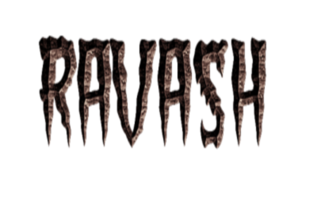

|  |
| --- |
| May 16th 2012 |

**Table of Contents**

1. Version History
2. Detailed Application Description
3. Controls
4. Screen Shots
5. Art / Multimedia Index

# Version History

Version 0.1 – The Very basic paint.py that was given out with minimal changes.

Version 0.2- This version is the first version of paint.py that was given out with the toolbar added to the left with basic buttons on the toolbar to show the GUI for now.4

Version 0.3 - I've added the Button class to easily create my buttons. Fixed an issue where the buttons weren't showing properly.

Version 0.4- In this version I have added many more features and buttons and started working on the images for the button. All of the buttons are appearing in the gui and majority of them work. I have the GUI to look more attractive by far. This version i split up code for drawing depending on what button/option is currently selected.

Version 1.0 – The Gui is finished and all buttons are working except for airbrush tool.

# 

# Detailed Application Description:

My program is very simple. The program loads up with an empty white canvas and a toolbar on the right with tools that allows the user to draw. The user is allowed to change the color and size of the lines being drawn. The user is able to save his picture or load a pre-existing picture to edit.

# Controls:

My program’s controls can be controlled 100% by mouse dragging and clicking. The user can click the buttons on the right to change which tool he/she wishes to use. The player also has the option to click keys to do the same as the buttons.

# Screen Descriptions:

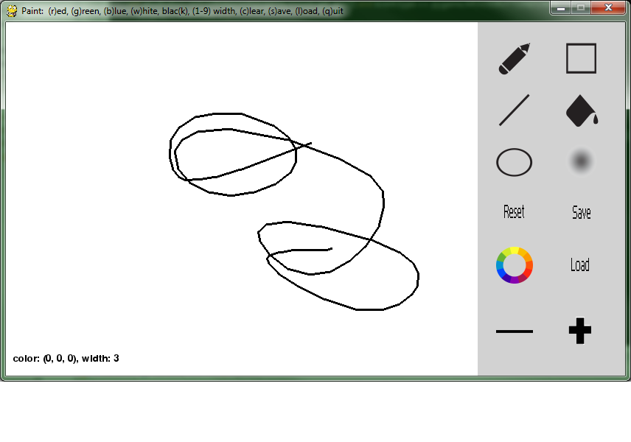

# 

# Art / Multimedia Index:

Thanks goes out to Mike Bastin for the custom button icons. Whatever he didn’t create for me in Photoshop I created myself.